Dragonflies
Autumn 1
2025-26
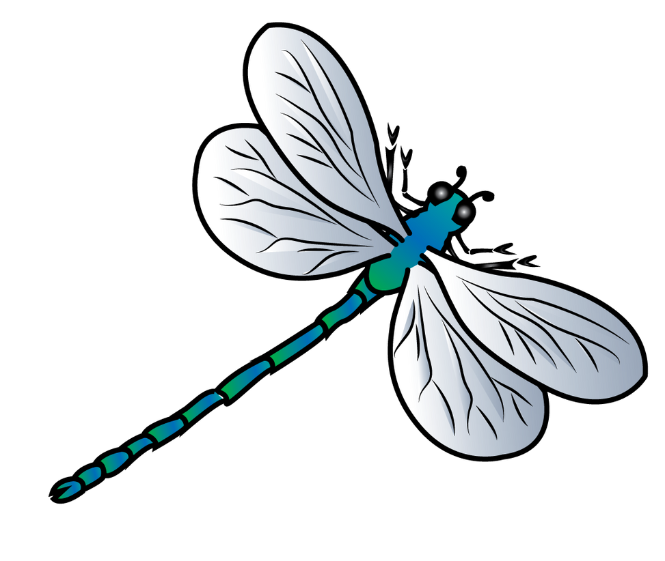
Computing:
The children will be finding out about technology all around us. They will be learning to use a keyboard and develop mouse skills
Music::
This term’s music lessons are based on a hip hop song ‘Hey You!’
The children will explore rhythm and will use their voices and instruments to improvise.

Phonics:
We will continue with our Little Wandle Phonics scheme.
We will start with recapping learning from Summer term in order to secure our knowledge. We will practise sounds, blending, reading tricky words, and sounding out skills in order to write words and sentences.

Maths:
Year 2 children will be learning about place value within 100. They will practise partitioning 2 digit numbers into tens and ones. They will also recap number bonds to 10 and learn number bonds to 20., including fact families ( 2+18=20, 18+2=20,20-2=18, 20-18=2.
Year 1 children will work with numbers within 10, comparing, ordering and saying 1 more/less than a given number. They will also start adding numbers within 10 and learn how to use a part-whole model to add 2 numbers.
English:
We will be basing our writing on the book by Benji Davies: The Storm Whale. We will practise writing well structured sentences in order to write our own story.
Guided Reading:
We will be using Collins Big Cat Books that are aligned with our phonics scheme. The children will have 3 reading session a week. We will focus on developing fluency and comprehension.
PSHE:
Our Jigsaw theme is ‘Being Me in My World’.
We will be learning about the importance of feeling safe in our school and will be discussing how to make people feel welcome. We will learn about our rights, responsibilities, achieve-ments and consequences.
Geography:
We will be exploring the geography of our local area, including the physical and human aspects. We will use Google Earth and maps to investigate.
R.E: Christianity
We will be exploring the question:
Does God want Christians to look after the world?

PE:
PE will be taught by Pro-coach on Monday afternoon. Children will be working on their ball skills (hit, run, catch) this half term.
They will need to bring a PE kit on the day as they will get change for PE in class.

Science:
We will be learning about the four seasons and observe the changes that happen in nature. We will observe weather and collect data. We will go on walks for first hand observation. We will create our own weather station in order to observe wind direction and rainfall.

Art:
We will be looking at techniques that Vincent Van Gogh used to create his art work. We will use sketching pencils, oil pastels and paints to practise our drawing and painting skills. We will look at some of Van Gogh’s famous artwork and create our own masterpieces.

